Kennedy died by a gun shot in the head, neck and the other missed by Lee Harvey Oswald on November 22ed 1963 at 12:30 p.m. in Dallas, Texas. While riding in a motorcade in the Dealey Plaza. He was riding with his wife, Texas Governor, and the Governor’s wife. There was proof that Oswald acted alone in shooting Kennedy. Oswald allegedly fired three shots from the sixth floor of the Texas Book Depository Building, fatally wounding President Kennedy and injuring the Texas Governor. Less than an hour after president Kennedy was shot, Oswald killed a police officer who questioned him on the street. Oswald was arrested in a movie theater 30 minutes after the shooting. Oswald was shot by Jack Ruby on his way to county jail the next day.
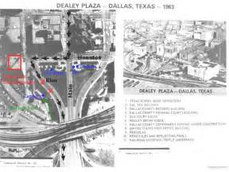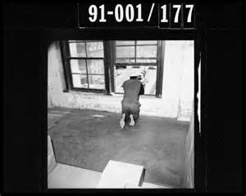
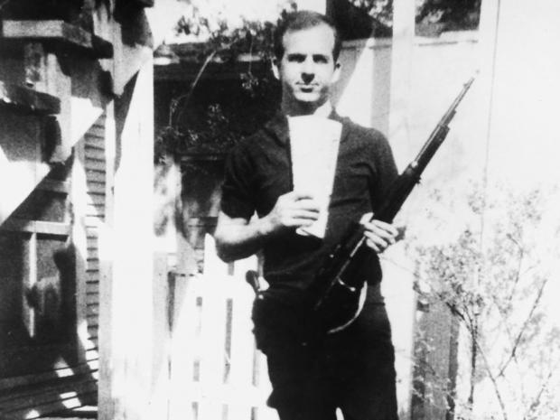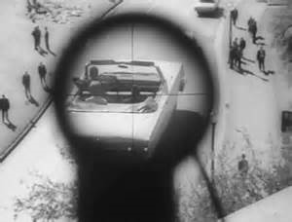
The picture of the map is where JFK got shot.
The picture of him leaning out the window is him aiming at JFK.
The picture of him and the gun is proof that he bought it.
And the picture of the gun pointed at JFK is proof that he shot him.

