Henry Ford
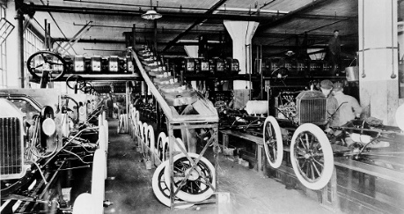
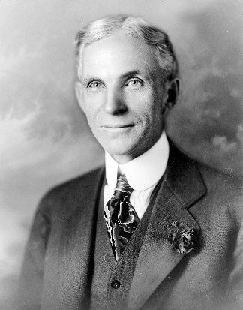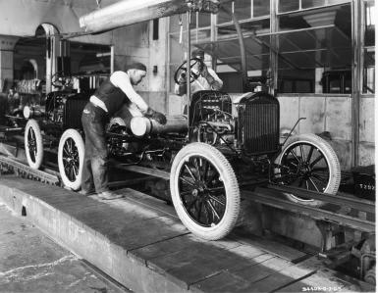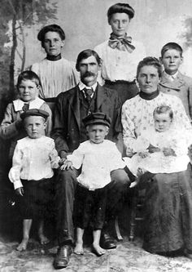
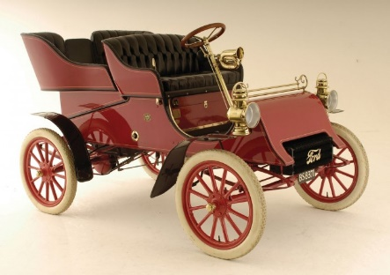

5 Interesting Facts:
1: Henry Ford began tinkering with a watch. When Henry Ford was in his early teens, his father gave him a watch, which Ford ended up dismantling and reassembling to work out how it operated. By the age of 15, Ford was known in his neighborhood as an unofficial watch repairman, working mostly for his friends.
2: American industrialist, Henry Ford (30th July, 1863 – 7th April, 1947) is best known as the founder of the iconic Ford Motor Company (FMC), though he was responsible for much more. Culturally, he revolutionized the transport industry with the development of the Ford Model T automobile that enabled the middle-class to own cars; automobiles had previously only been affordable for the upper classes. In business, he’s credited with pioneering mass production and establishing better working conditions and entitlements for employees.
3: Henry Ford’s first successful company became a competitor. After Ford’s failure with his initial company, he established another with C. Harold Willis. The two developed a vehicle together. They gained attention for the car after racing it, and the subsequent attention led to investors. With further funding from William H. Murphy, Ford and Willis established the Henry Ford Company in 1901, with Ford serving as the chief engineer.
4: Henry Ford embarked in Brilliant, but questionable business practices. In 1918, in what would prove to be a genius move, Ford handed the presidency of the FMC to his son, Edsel Ford. However, Henry still had the final say over each decision made. Meanwhile, Henry established the business Henry Ford and Son, for which he employed his most skilled workers from the FMC.
5: Ford pioneered the idea of welfare capitalism, which was intended to improve the quality of life of his employees. In 1914, Ford established the $5 day wage (approximately $110 by today’s standards), which at the time was more than double the average wage. The strategy proved beneficial for both Ford and his employees. Many of the best mechanics in the Detroit pursued careers with the company, which in turn increased productivity and reduced the cost and need for training. Subsequently, other auto businesses in Detroit were essentially forced to raise their own wages.

