Jeffrey Dahmer
- Born and raised in Milwaukee, Wisconsin on May 21st, 1960. Died on November 28, 1994.
- Jeffery Dahmer killed men and teenagers after luring them home. He mutilated, photographed and performed sexual acts on the victims’ corpses and kept their body parts as mementos. I think that he is disgusting because that is not something any normal person would do. I think he belongs on the most deviant list because he sounds like a psychopath. He died in prison, which is good because if not I feel that he should have been sentenced to the death penalty.

John Wayne Gacy
- Born and raised in Chicago, Illinois on March 17, 1942. He died due to the death penalty by lethal injection on May 10, 1994.
- John Wayne Gacy participated in magic shows for children dressing up as “Pogo the Clown”. John kidnapped and murdered more than 30 men and boys, torturing and killing them after sexual intercourse. He buried the bodies below and around his home. I think he is sick because he dressed up as a clown to try and get children to like him. Guys like him are why people fear clowns.
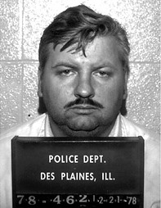
Edward Gein
- Born and raised in La Crosse, Wisconsin on August 27, 1906. He died from heart failure due to cancer on July 26, 1984.
- After Edward Gein’s mother died, he started robbing graves and keeping his findings as trophies. He would dig up the females that were recently buried in the graveyard and practice necrophilia, which is having sexual intercourse with dead bodies. He also skinned them and made furniture out of human skin, such as a lamp shade and a chair. He had a human heart in a jar above his stove, as well. He is deviant because he disturbed the resting. He could also give diseases to alive women because of him practicing necrophilia.
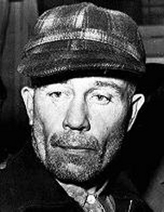
Aileen Wuornos
- Aileen Wuornos was born in Rochester, Michigan and moved around. She died October 9, 2002.
- As a child, Aileen was in a tough home because her father killed himself in prison when he was sentenced for child molestation and her mother abandoned her, leaving them her to be raised by her grandparents, who were alcoholics. Aileen was sexually abused as a teenager by her grandfather and brother and was thrown out of her home because she became pregnant, but the child was adopted. She made a living as a sex worker on Florida highways. She eventually started killing the men who picked her up. She is deviant because most serial killers are men, whereas she is not.

Adolf Hitler
- Born on April 20, 1889 in Braunau am Inn, Australia. He died on April 30, 1945 in Berlin, Germany.
- Unlike all the other people on my list, Adolf was not a cannibal or anything like that. He was kind of a seral killer, though. He believed that all the bad in the world was because of the Jews. He made all the Jews were the Star of David on their clothing and put it on the stores owned by Jews so people were aware of who they were talking to or who they were buying from. He is a bad person because he is just a big racist who got others to believe they were bad, too.

